Session-3
Task-1 : Create an HTML form for a Flipkart-style product review, including input fields for username, rating (as a dropdown from 1 to 5), and a textarea for the review message. Use appropriate labels for each field.
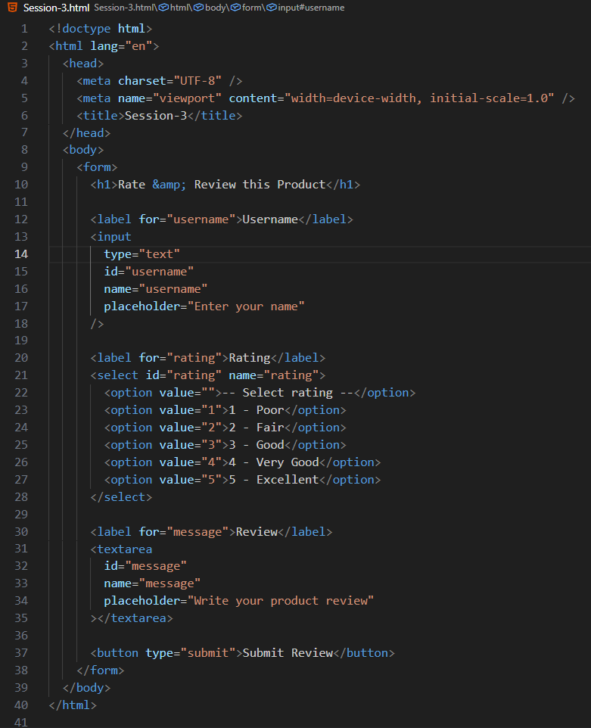

Task-2 : Add HTML5 validation attributes to your review form so that username is required, rating must be selected, and the review message must be at least 20 characters long.<br><br><em><strong>Hint:</strong> Use required, minlength, and a default unselectable option for the dropdown.</em>
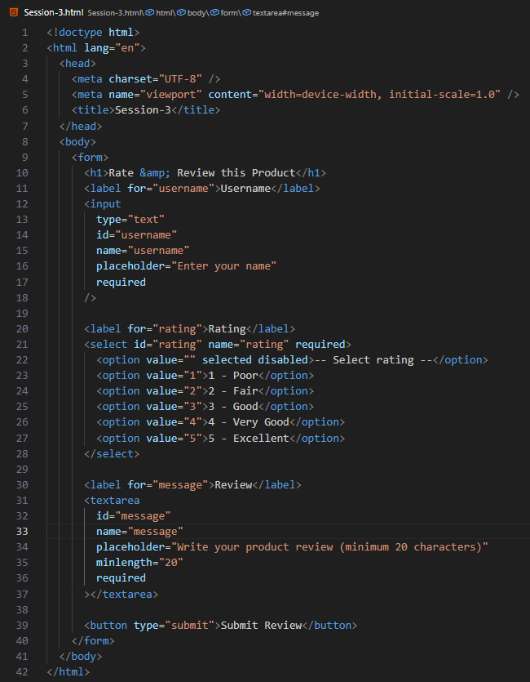

Task-3 : Modify your form to use the POST method and, after submitting a test review, open the DevTools Network tab to preview the POST request data sent by your form.<br><br><em><strong>Hint:</strong> Look for the form submission request and expand the payload/details to see your input values.</em>

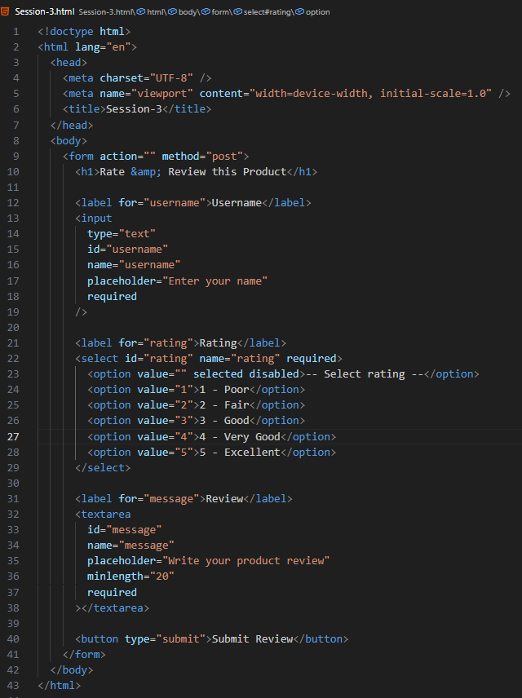

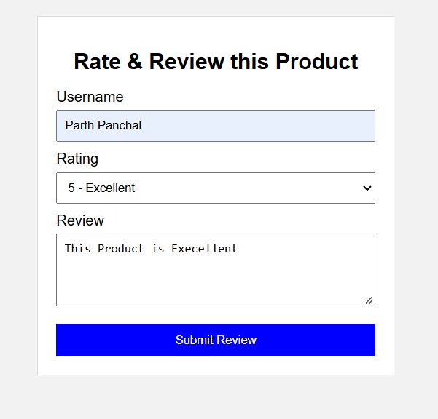

The Network tab displays the following submitted data
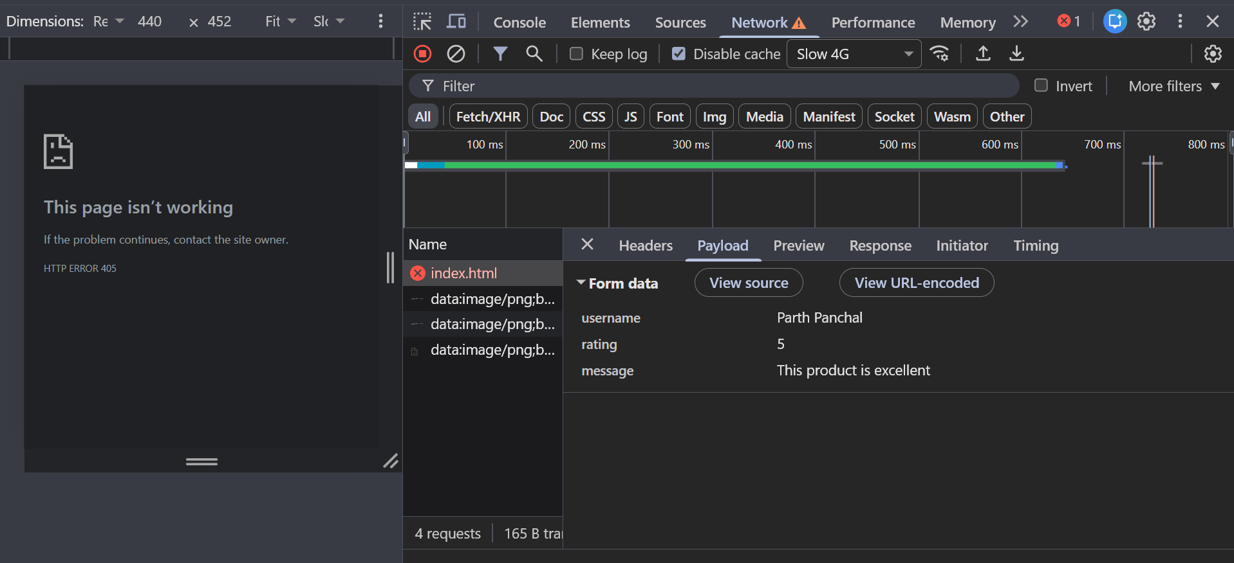

Task-4: Build a Zomato-style food order form with inputs for user name, a select dropdown for food item (at least 3 options), quantity (number input), and a textarea for delivery instructions. Ensure all fields are labeled and use required validation.
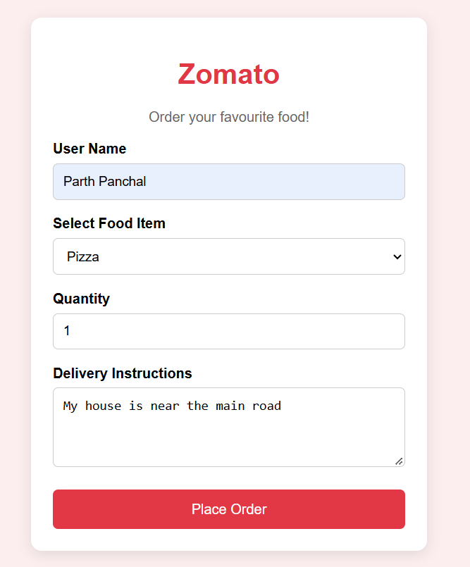

Task-5: Add a disabled input field to your food order form that displays a fixed order ID (e.g., ORD12345) and explain in a comment why this field should be disabled for users.
